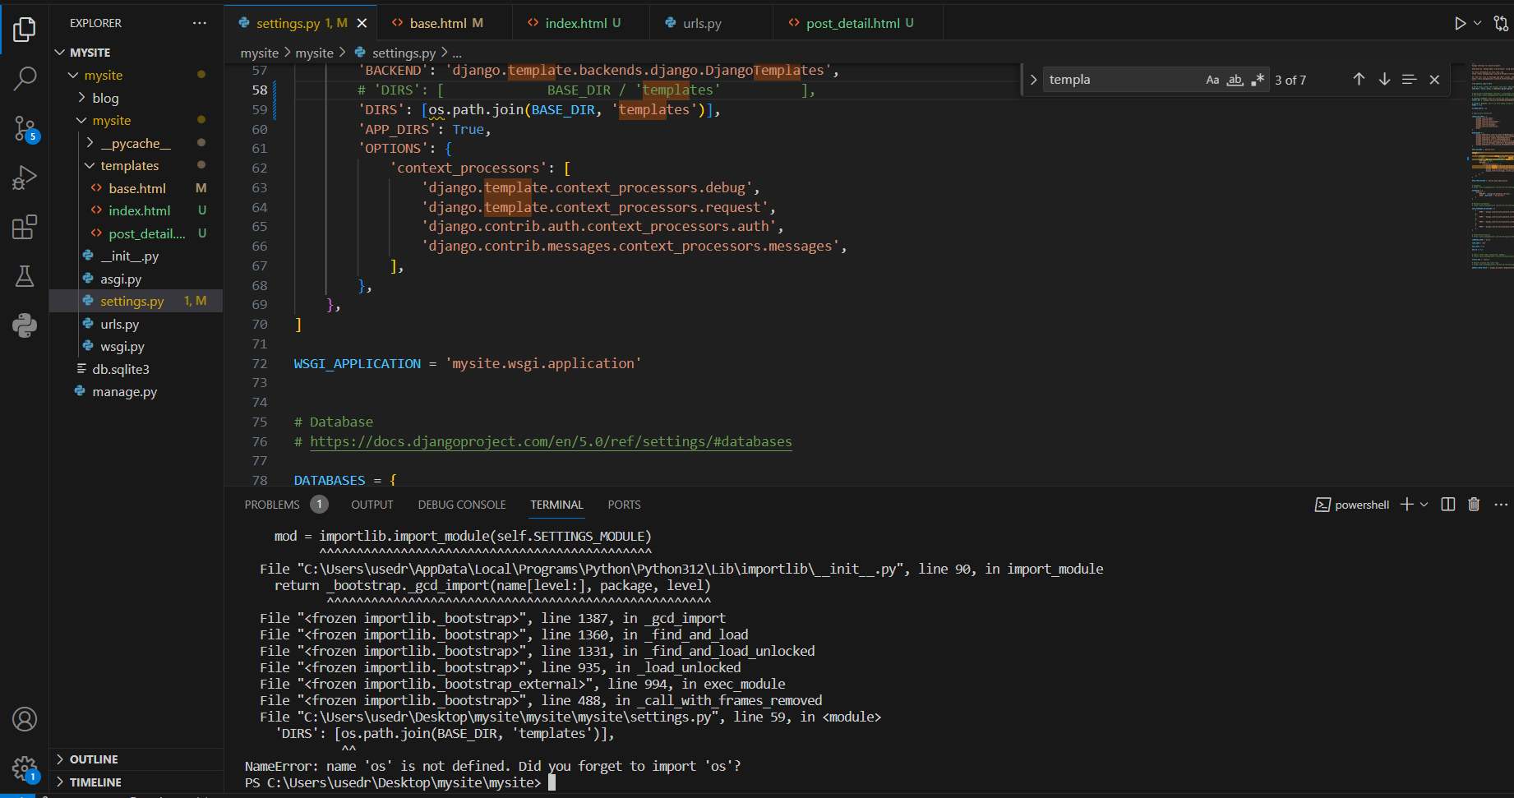

TemplateDoesNotExist at /

index.html, blog/post_list.html

|  |  |
| --- | --- |
| **Request Method:** | GET |
| **Request URL:** | http://127.0.0.1:8000/ |
| **Django Version:** | 5.0 |
| **Exception Type:** | TemplateDoesNotExist |
| **Exception Value:** | index.html, blog/post_list.html |
| **Exception Location:** | C:\Users\usedr\AppData\Local\Programs\Python\Python312\Lib\site-packages\django\template\loader.py, line 47, in select_template |
| **Raised during:** | blog.views.PostList |
| **Python Executable:** | C:\Users\usedr\AppData\Local\Programs\Python\Python312\python.exe |
| **Python Version:** | 3.12.1 |
| **Python Path:** | ['C:\\Users\\usedr\\Desktop\\mysite\\mysite',  'C:\\Users\\usedr\\AppData\\Local\\Programs\\Python\\Python312\\python312.zip',  'C:\\Users\\usedr\\AppData\\Local\\Programs\\Python\\Python312\\DLLs',  'C:\\Users\\usedr\\AppData\\Local\\Programs\\Python\\Python312\\Lib',  'C:\\Users\\usedr\\AppData\\Local\\Programs\\Python\\Python312',  'C:\\Users\\usedr\\AppData\\Local\\Programs\\Python\\Python312\\Lib\\site-packages'] |
| **Server time:** | Mon, 14 Oct 2024 11:50:25 +0000 |

**Template-loader postmortem**

Django tried loading these templates, in this order:

Using engine django:

* django.template.loaders.filesystem.Loader: C:\Users\usedr\Desktop\mysite\mysite\templates\index.html (Source does not exist)
* django.template.loaders.app_directories.Loader: C:\Users\usedr\AppData\Local\Programs\Python\Python312\Lib\site-packages\django\contrib\admin\templates\index.html (Source does not exist)
* django.template.loaders.app_directories.Loader: C:\Users\usedr\AppData\Local\Programs\Python\Python312\Lib\site-packages\django\contrib\auth\templates\index.html (Source does not exist)

Using engine django:

* django.template.loaders.filesystem.Loader: C:\Users\usedr\Desktop\mysite\mysite\templates\blog\post_list.html (Source does not exist)
* django.template.loaders.app_directories.Loader: C:\Users\usedr\AppData\Local\Programs\Python\Python312\Lib\site-packages\django\contrib\admin\templates\blog\post_list.html (Source does not exist)
* django.template.loaders.app_directories.Loader: C:\Users\usedr\AppData\Local\Programs\Python\Python312\Lib\site-packages\django\contrib\auth\templates\blog\post_list.html (Source does not exist)